

**Back End Project Report**

*Submitted to: Mr. Ashwani Dubey*

Submitted by: JATT ON WHEELS

AAYUSH KATOCH– 2110990028

AAYUSH TOMAR – 2110990032

ABHIJAY SHARMA – 2110990039

ADITYA ARORA– 2110990082

AKHILESH STAN- 2110990120

**Key Points :-**

1. **Introduction**
   * Overview of the Expense management system
   * Technologies Used (React, Node.js, MongoDB)
2. **Why Choose Us?**
   * Unique Features and Functionalities
   * User-Friendly Interface
3. **Challenges Faced**

Technical Challenges

* + - Integration of React and Node.js
    - Database Design and Implementation

1. **Goals**
   * Improved User Experience
   * Scalability and Performance
   * Responsive Design for Multiple Devices
   * Enhanced Security Measures
   * Efficient Data Management with MongoDB
2. **Project Achievements**
   * Positive User Feedback
   * Manages your expenses
   * Helps you to keep a track of your expenses

1. **Future Expectations**
   * Continuous Improvement of Features
   * Integration of AI for Personalized Recommendations
   * Expansion of Destination and Service Offerings
   * Enhanced Data Analytics for Business Insights
   * Integration with External APIs for Additional Services
2. **Conclusion**
   * Summary of Key Achievements
   * Acknowledgment of Challenges Overcome
   * Commitment to Continuous Improvement

SIGN UP&LOGIN PAGE:

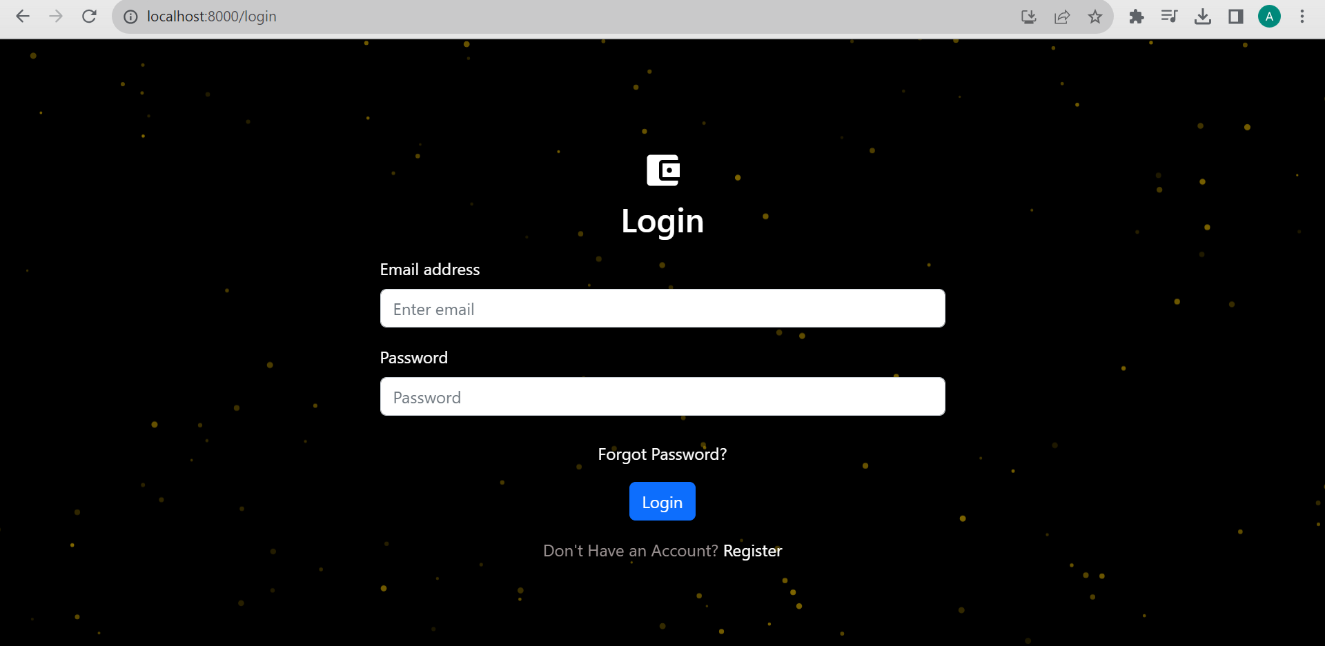

SOME INTERACTIVE FEATURES:



We thought there was a need of more interaction so we used this emoji’s to make the page fun and interactive.

**2. Why Choose Us?**

**Unique Features and Functionalities**

Our platform stands out with unique features such as interactive maps, personalized itineraries, and real-time travel updates. The use of React allows for a dynamic and engaging user interface, providing an immersive experience for our users.

**User-Friendly Interface**

The website boasts an intuitive and user-friendly interface, ensuring that users can easily navigate through various destinations, explore travel packages, and make bookings effortlessly.

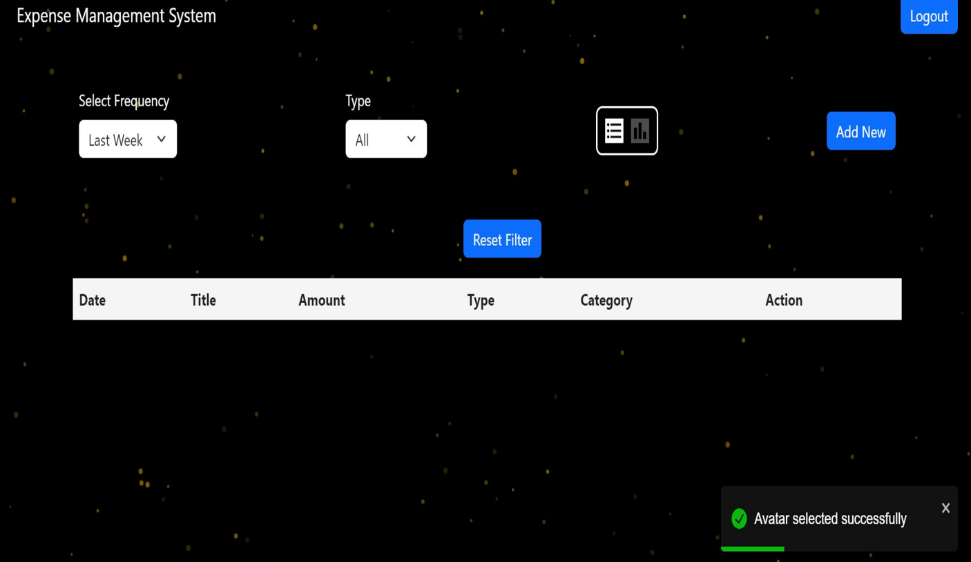

**4. Goals:**

**Improved User Experience**

The React-based frontend provides a responsive and visually appealing interface, enhancing the overall user experience and encouraging user engagement.

**Scalability and Performance**

Node.js on the backend ensures high performance and scalability, allowing the platform to handle a growing number of users and transactions efficiently.

**Responsive Design for Multiple Devices**

The website's responsive design ensures optimal performance across various devices, providing a consistent and enjoyable experience for users on desktops, tablets, and smartphones.

**Enhanced Security Measures**

Implementing best security practices on both frontend and backend layers ensures the safety and privacy of user data, fostering trust among our users.

**Efficient Data Management with MongoDB**

MongoDB's flexible and scalable data model enables efficient storage and retrieval of travel-related information, contributing to the platform's speed and responsiveness.

**5. Project Achievements**

**Positive User Feedback**

Users have provided positive feedback on the website's design, ease of use, and the overall travel booking experience, reflecting the success of our user-centric approach.

**Efficient Booking and Reservation System**

The booking and reservation system has proven to be efficient and reliable, contributing to a high conversion rate and customer satisfaction.

**Integration of Real-Time Updates for Users**

Real-time updates and notifications have improved user engagement and satisfaction, providing users with timely information on their travel plans.

**6. Future Expectations**

**Continuous Improvement of Features**

Our commitment to providing the best user experience drives continuous improvement, with plans to introduce new features and enhancements regularly.

**Integration of AI for Personalized Recommendations**

Future iterations may incorporate AI algorithms to analyze user preferences and offer personalized travel recommendations, further enhancing the user experience.

**Expansion of Destination and Service Offerings**

We aim to expand our range of destinations and services, providing users with a broader array of travel options and experiences.

**Enhanced Data Analytics for Business Insights**

Implementing advanced data analytics tools will offer valuable business insights, helping us make data-driven decisions to improve the platform's performance and user satisfaction.

**Integration with External APIs for Additional Services**

Collaboration with external service providers through APIs will allow us to offer additional services such as travel insurance, local guides, and more, enriching the overall travel experience.

**7. Conclusion**

In conclusion, the Expense management website project has successfully leveraged React, Node.js, MongoDB to create a dynamic and user-friendly platform for big spenders. Despite challenges faced during development, the project has achieved significant milestones, with positive user feedback and increased engagement.